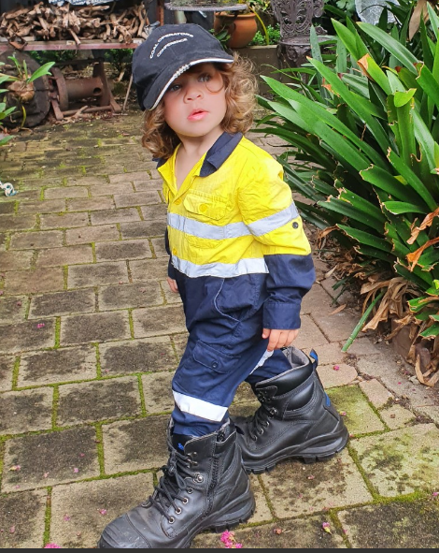
Conf. Mascot Lucidna

CONFERENCE PROGRAM
Resource Operators Conference
9-10 February 2023
McKinnon Building 67
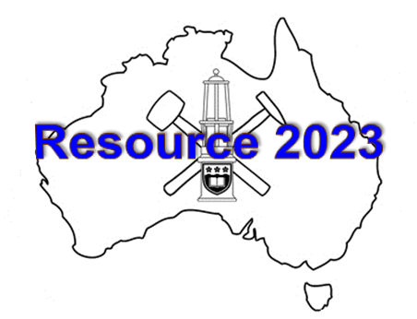
Thursday 9th February 2023
7.30 - 8.150 am Registration and Coffee
8.15 - 8.30 am Welcome and Plenary- Chair: Naj Aziz
1. Special Industry Guest Speaker – Peter Baker, Vice President Operations, South32: An overview of South32 operations in Illawarra
9.0 - 10.30 am Technical Session I - Chairs: Yvette Heritage / Eleonora Widzyk-Capehart
2. David Walker, Ernest Baafi, Senevi Kiridena: An approach to solve underground coal mine logistics strain
3. Richard Campbell, Ravindu Goonawardene, Ismet Canbulat: The optimisation of ground consolidation practices in longwall coal mining applications
4. Ken Mills, Stephen Wilson: Observations of multi-seam subsidence at Ashton underground mine
10.30 - 11.00 am Morning Tea
11.00 - 12.30 pm Technical Session II - Chairs: Jan Nemcik / John Hoelle
5. Ian Gray, Tim Gibbons: A structural engineering approach to longwall rock mechanics in massive structure
6. Gaetano Ventichenque: 3D rock failure modelling of pillar behaviour during longwall retreat into normal and angled design gas drainage stubs
7. Xiaohan Yang, Mehdi Serati, Paul Buddery: Brittle-ductile transition in coal pillar failures
12.30 - 1.30 pm Lunch
8. Special Industry Guest Speaker - Gerald Linde, General Manager, Whitehaven Coal: Overview Narrabri coal operations – challenges and future plans. Introduction by Naj Aziz

[Introduction by Naj Aziz]
2.00-3.30 pm Technical Session III - Chair: Richard Campbell
9. Alex Remennikov, Edward Chern Jinn Gan: Defining explosion risk exclusion zones around coal mine openings in emergency situation
10. Dennis Black: Outburst control in the Wongawilli seam
8. 11. Frank Hungerford: Reduction of fugitive methane emissions from open cut coal mines
3.30 - 4.00 pm Afternoon Tea
4.00 - 6.00 pm Technical Session IV - Ali Mirzaghorbanali / Adam Raine
12. Mark Kleinhans, Glenn Aitchison,: Fighting mine fires with a small turbine engine
13. Sebastian D’Hyon, Shevaune Zeng: Alternative spontaneous combustion testing methods
14. Jon Roberts, Rongfu Liao, Ming Qiao, David Hastie, Peter Wypych: Research into the selection and efficiency of nozzles for airborne dust suppression
15. Ting Ren, Ming Qiao, Jon Roberts, Jennifer Hines: Monitoring and computational modelling of ventilation and dust flow in development panel
Conference Dinner 7.00 for 7.30 pm; Lucia by the sea, 16 Cliff Rd, Wollongong NSW 2500

Sponsors

Friday 10th February 2023
16. 8.00 am A Keynote Speaker: Charlie Li: Energy sources of rock burst and the influence of the surrounding rock mass - Introduction by Naj Aziz
8.30 - 10.30 am Technical Session V - Chair: Ian Gray/ Dennis Black

17. Peter Craig, Matthew Holden: Pumpable two-part resin cable bolt bonding material tests
18. Kent McTyer: Practical tests of the impact of mixing time and cure time on resin-anchored rock bolts
19. Sina Anzanpour, Naj Aziz, Jan Nemcik, Ali Mirzaghorbanali, Alex Remennikov: An update on load transfer characteristics of tendon under static and dynamic test conditions
20. Hadi Nourizadeh, Ali Mirzaghorbanali, Naj Aziz, Kevin McDougall, Behshad Shokri Jodeiri, Ali Akbar Sahebi, Amin Mottalebiyan, Shima Entezam: Finite element numerical modelling of rock bolt axial behaviour subject to different geotechnical conditions
10.30 - 11.00 am Morning Tea

11.00 - 1.00 pm Technical Session VI - Chair: Peter Craig / Kevin Marston
21. Vihanga Peiris, Kai Zhao, Binghao Li, Henry Gong, Aruna Seneviratne: Preliminary studies of an energy efficient BLE wireless network for underground positioning systems
22. Yangguang Han, Kumari W.G.P, Lloyd White, Dominique Tanner, Titus Murray: Investigating a potential geothermal play in the southern Sydney Basin
23. David Walker, Chris Harvey, Ernest Baafi, S Kiridena, Ian Porter: Movement of personnel and materials in Australian underground coal mine
24. Petr Waclawik, Radovan Kukutsch, Kristyna Schuchova, Jan Nemcik, Andrzej Walentek, Alexander Wrana, Sahendra Ram: Deformation analysis in the surroundings of the roadway ahead of longwall mining, Staszic-Wujek Mine, Poland
End of Technical Presentation and Conference Closure
BBQ at Lawn
ADDITIONAL PAPERS
Additional papers in the conference proceedings are also published online
25. Zhenjun Shan, Ting Ren, Douglas Pateman, Guanzheng Wu, Jan Nemcik, Hongchao Zhao, Xiaohan Yang: Experimental study on the uniaxial compressive behaviour of a FRP standing support
26. Sadjad Mohammad, Mohammad Atae, Reza Kakai, Ali Mirzaghorbanali, Naj Aziz, Ashkan Rastegarmanesh: Numerical simulation of stress distribution in longwall panels during the first caving interval
27 Behshad Jodeiri Shokri Shima Entezam, Hadi Nourizadeh, Amin Motallebiyan, Ali Mirzaghorbanali, Kevin McDougall, NajAziz, Karu Karunasena: The effect of changing confinement diameter on axial load transfer mechanisms of fully grouted rock bolts
28. Bharath Belle, Rao Balusu: Longwall maingate and tailgate proactive spon.com and gas management strategy - a safety share on risk management
29. Shima Entezam, Behshad Jodeiri Shokri, Hadi Nourizadeh, Amin Motallebiyan, Ali Mirzaghorbanali, Kevin McDougall, Naj Aziz, Karu Karunasena: Investigation of the effect of using fly ash in the grout mixture on performing the fully grouted rock bolt system
30. Behshad Jodeiri Shokri, Shima Entezam, Alireza Entezam, Ali Mirzaghorbanali: Investigating the effect of coal macerals on the recovery rate of the flotation process- A case study
31. Amin Motallebiyan, Hadi Nourizadeh, Behshad Jodeiri Shokri, Shima Entezam, Ali Mirzaghorbanali, Naj Aziz, Kevin McDougall: Effects of rib distances on axial load transfer mechanisms of fully grouted rock bolts
32. Al Muhalab Al-Dughaishi, Shivakumar Karekal, Fok Tivive: Slope stability prediction using the Artificial Neural Network (ANN)
34. Yohanne Faivre, Ali Mirzaghorbanali, Hadi Nourizadeh, Behshad Jodeiri Shokri, Kevin McDougall, Naj Aziz: SPT-CPT correlation in Southeast Queensland, Australia
35. Raza Akhtar, Graham Skellern, Ali Mirzaghorbanali: Substitution of recycled plastic aggregates (RPA) in concrete and its influence on pullout capacity of mechanical and chemical anchors
36. Kieren Russell, Ting Ren: Respirable dust generation and mitigation in Australian underground coal mine development heading – applications of computational fluid dynamics for respirable dust modelling
37. Elizabeth Downing, Ali Mirzaghorbanali, and Naj Aziz: Shear strength properties of clean and clay infilled rock joints: an analysis of the impact of moisture content under CNL conditions

Supporters

